Journal of Contemporary Eastern Asia
ISSN 2383-9449

Jiang Li, Weiai Wayne Xu, Fang Wang, Si Chen, and Jianjun Sun

Examining China’s Internet Policies through a Bibliometric Approach

Journal of Contemporary Eastern Asia Vol. 17, No. 2: 237-253
DOI: 10.17477/jcea.2018.17.2.237

www.jceasia.org
www.watef.org

Open Access Publication
Creative Commons License
Deed Attribution-No Derivative Works 3.0

Journal of Contemporary Eastern Asia Vol. 17, No. 2: 237-253
DOI: 10.17477/jcea.2018.17.2.237

Examining China’s Internet Policies through a Bibliometric Approach

Jiang Li
Weiai Wayne Xu
Fang Wang
Si Chen
Jianjun Sun

In order to understand China’s internet governance, this paper examined 1,931 Internet policies of China by bibliometric techniques. Specifically, the bibliometric techniques include simple document counting, co-word analysis, collaboration network analysis and citation analysis. The findings include: (1) China’s Internet legislations mainly emphasized e-commerce and Internet governance, and, to some extent, neglected personal data protection; (2) China’s Internet is under intensive multiple regulatory controls by central government. A large number of government agencies are involved in Internet policy-making. The Propaganda Department of the Central Committee of the Communist Party of China and the State Information Leading Group of the State Council, enforced fewer policy documents, but occupy higher positions in the Internet governance hierarchy; (3) China’s Internet legislation system is primarily composed of industry-specific administrative rules, rather than laws or administrative regulations. Nevertheless, laws and administrative regulations received significantly more citations owing to their superior force. This paper also discussed current gaps in China’s internet governance and how the country’s internet policies are situated in the broader global context.
Keywords: Internet Policy, China, Internet governance, Bibliometric techniques, Networks

Introduction
China has the world’s largest internet population and boasts one of the largest internet economy (CNNIC, 2015). Internet brought not only considerable benefits to China’s economy, but also a challenge to the dominance of the Communist Party of China. The most critical mechanism of China’s internet control is content censorship. There has formed a sophisticated system of laws, regulations, and technologies for content censorship on the Internet, targeting sensitive political information, obscenity, and other information that the government defines as threatening or objectionable (Dong, 2012; McDonald, 2015; Zittrain, 2003). Alongside the control of the Internet for political purpose, the Chinese government implements policies that disadvantage foreign companies. Foreign investment is banned in certain internet services such as news reporting. Those allowed must partner up with local state-owned enterprises and have no controlling share (NDRC, 2015). The characteristics of China’s internet policy, its focus on political control and its favoritism towards local companies are consistent with Chinese governmental goals of using the Internet for both economic development and promotion of political agenda. This is, to a certain degree, different from the guiding principles, including freedom, privacy, security, and equality, for internet policy in western democratic countries, e.g., Germany, Finland, Sweden, US, etc. (Kluver, 2005; Löblich and Karppinen, 2014). China’s internet policy also reflects a clash of values in the global internet governance (i.e., the processes that impact how the Internet is managed): national governments (notably China and Russia) increasingly claim cyber-sovereignty—the notion that national governments have the right to police domestic cyberspace just as they defense national borders (Yuen, 2015). While the West (the U.S. and Europe) typically promotes freedom of expressions. Even in Asia, China’s internet policy is one of the examples of hindering the development of content and sometimes applications on the internet (Is slam and Hoq, 2010; Xue, 2005). The conundrum of the Chinese internet - its dynamic ecosystem and economy, along with the lack of freedom and transparency, bears the imprint of China’s unique internet governance (Jiang, 2012). Therefore, the case of Chinese internet governance not only offers insights into the struggles and growth within the Chinese cyberspace, but also reflects how narratives on global internet governance are to be shaped by conflicting interests of governments, business, and public interests.

This study seeks to study China’s internet policy documents. Due to a large scale of documents present, the study resorts to an efficient yet informative analytic approach – informatics approach. This approach has been increasingly used in policy analyses. It enables an objective and precise identification of key actors and concepts in the policy-making process (Debackere, 2004). To that goal, the study is organized as follows: first, a review of the development of the internet in China is provided, followed by an introduction of informatics—specifically, bibliometric approaches for policy analyses. Research questions are then proposed based on the literature review.

The Path and Structure of Chinese Internet Governance

China’s policy system is constituted by agencies of three different administrative levels. First and foremost, the National People's Congress (NPC) and its Standing Committee (SCNPC) make laws of the highest legal force. NPC is an equivalent of the Parliament or Congress in the West. Second, inferior to the laws, administrative regulations are issued by the State Council (SC) and the Central Committee of the Communist Party of China (CCCPC). Third, ministries and departments formulate industry-specific administrative rules of the lowest force, or administrative replies whose effect is limited to these ministries and departments. The lower levels of legislations are promulgated based on the high-level ones. Administrative replies are not legislations, but decisions that apply legislations to specific cases.

The governance agencies of the Internet in China are summarized and shown in Figure 1. The State Information Leading Group (SILG), affiliated by the State Council, promulgated only 12 policy documents on the Internet. However, SILG was granted with extensive powers on China’s Internet governance. The leader of the SILG is usually the Premier of China. Affiliated to the SILG, the State Information Office (SOI) undertook the task of driving telecommunication policy agenda. It was abolished in March 2008, prior to which it promulgated five Internet policies. In 2011, the Cyberspace Administration of China (CAC) was established, accepting similar responsibilities. Apart from the governance from the SC, China’s Internet is also under the governance of the CCCPC. The Propaganda Department (PD) of the CCCPC is responsible for information dissemination and management, although it issued only four Internet policies. In the system of the PD, the GAPP and the SARFT must accept orders from it (Lieberthal and Burns, 1995). In 2014, the Office of the Central Leading Group for Cyberspace Affairs (OCLGCA) was established, to promote the construction of cyber security and information legalization. Its group leader is the state president.

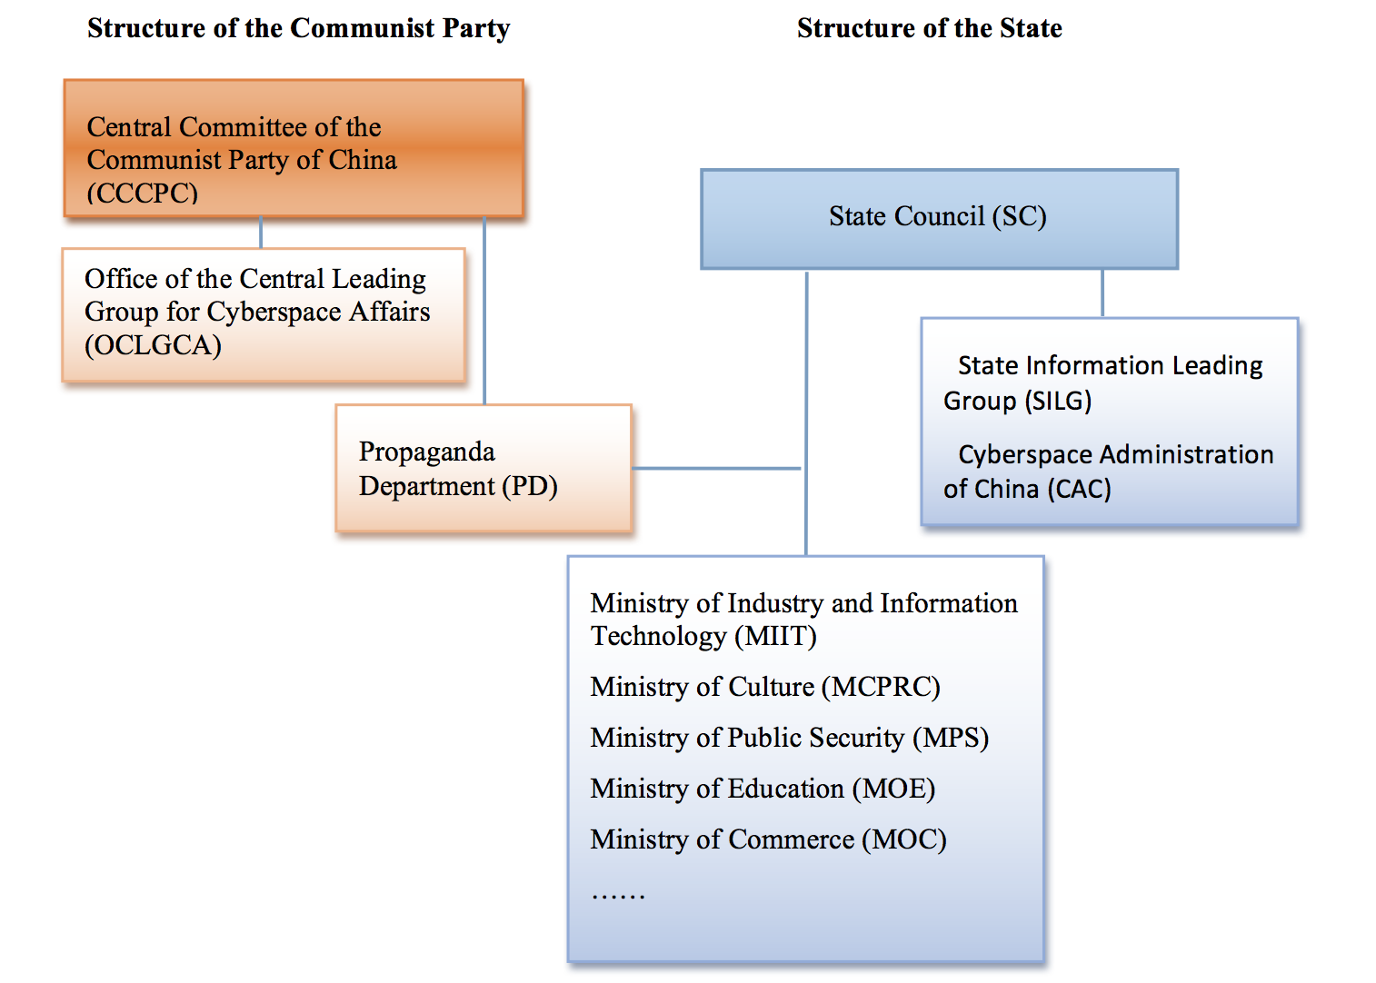
Figure 1 The structure of the Central governance agencies of internet in China

Bibliometric Approach for Policy Analysis

The extant literature on internet governance, and in particular on Chinese internet governance, is predominantly qualitative, which has the benefit of thick description, but may lack precision and objectivity. A few previous studies referred to the quantitative aspects of public policies, Sun et al. (2009) quantitatively studied the power, goals and means of Chinese technology policies (Sun et al., 2009). This quantification was also applied to innovation policies (Liu and Sun, 2007). and higher education policies (Tu, 2007). However, its critical limitation is that it heavily relies on subjective interpretation which to a certain extent leads to score-assignment bias. Bibliometric techniques feature documents by numbers. Usually, large numbers indicate great achievement or strong intention of document-owners. Several examples show how such approach is used to analyze a country’s science policies. Huang et al. (2014) revealed that China’s basic research was overshadowed by quantitatively analyzing the categories of science and technology policies Huang et al., 2014). Huang et al. (2015) explained the historical evolution of China’s science and technology policies by quantifying the topics of policies and the involvement of policy-making agencies (Huang et al., 2015). While quantitative analysis of policies is growing in numbers, there is a still dearth of quantitative analysis of internet policies. Quantitative analysis becomes important when researchers face increasingly large-scale policy documents that make manual reading difficult.

This study introduces a computer-assisted bibliometric approach to examine structure and connections within internet policy documents. This approach has received a broader application. For example, it has been used to study the quantitative aspects of online communication, a subfield known as “Webometrics”, as introduced by Almind and Ingwersen (Almind and Ingwersen, 1997), and further defined by Björneborn and Ingwersen (Björneborn and Ingwersen, 2004). Tague-Sutcliffe introduced several such uses of bibliometrics (Tague-Sutcliffe, 1992) : (1) statistical aspects of language, word, and phrase frequencies, in both natural language texts and indexes; (2) characteristics of authors: productivity measured by number of papers, degree of collaboration; (3) citation analysis: distribution over authors, papers, institutions, journals and countries; etc. These bibliometric methods can also be applied to public policies, considering that policy documents are semi-structured, making computer-assisted text mining possible. Specifically, the application of the bibliometric approach to policy analyses can yield the following insights: (1) longitudinal trends in policy-making, (2) salience of and connections between topics and (3) connections among different entities (policy-makers and enforcers). Following the three types of insights, three research questions are proposed:

RQ1: How has China’s internet policy evolved over time?
RQ2: What topics and how are different topics covered in China’s internet policy documents?
RQ3: How do different policy-making actors connect with one and another in policy-making and implementation?

Data and methodology

A total of 1,931 internet policies in Mainland China were collected from two Chinese-language databases: Chinalawinfo (www.chinalawinfo.com) and Lawyee (www.lawyee.net), as well as the official website of the China Internet Network Information Centre (CNNIC, www.cnnic.cn). The Chinalawinfo has the largest coverage of China’s public policies, including approximately 200,000 documents of Chinese laws, regulations, rules, judicial interpretations, local regulations and local rules from 1949 to the present. By contrast, the Lawyee covers only 17,000 documents and was therefore used as a supplemental source. The third source, CNNIC, is a nonprofit organization affiliated with the Chinese Academy of Sciences, and is responsible for the administration and service of China’s fundamental Internet resources, e.g., domains, IP addresses, etc.

To retrieve relevant policies, we first searched in policy title with such keywords as “hu lian wang” (Internet), “wang luo” (web or network), “yu ming” (domain), “wang zhan” (website), "URL", "dian zi shang wu" (e-commerce) and "dian zi zheng wu" (e-government). Second, we collected policies in the “Internet” classification in the two databases which do not contain any of the above keywords in their titles. Third, we retrieved all policies from the website of the CNNIC. Then, a manual check was conducted to remove duplicates and less relevant policies from the raw data.

Because policy documents are semi-structured (see Figure 2 for an example), it is possible to use computer codes to automate data parsing. Specifically, in the example in Figure 2, the title, affiliations, issue year and category of a policy are directly listed in policy document. The topics of policy can be manually identified by a few keywords and phrases. For example, the topics of the exemplar policy can be labelled by “Internet information service”, “market order”, etc., which are selected from the Thesaurus of official documents of the State Council and the Classified Chinese Thesaurus (The Editorial Board of the Chinese Library Classification, 2005). The thesaurus includes standard vocabularies used by the Chinese government in its official documents. The references of a Chinese policy, the most appealing feature of the bibliometric application, are usually labelled by the symbols “«” and “»” in the first or last paragraph of its text, i.e., the «Regulation on Telecommunications of the People's Republic of China» and the «Administrative Measures for Internet Information Services», as cited by the exemplar policy. The identified reference patterns are loaded for citation analysis. Citation analysis is applicable to public policies, given the reference relationship built between policies. To address RQ1, the computer script first extracted the issue year and agencies of each policy. To address RQ2, two to five keywords from the Thesaurus of official documents of the State Council and the Classified Chinese Thesaurus were used to label the themes of each policy. To address RQ3, the references of each policy were identified through the textual symbols “«” and “»”.

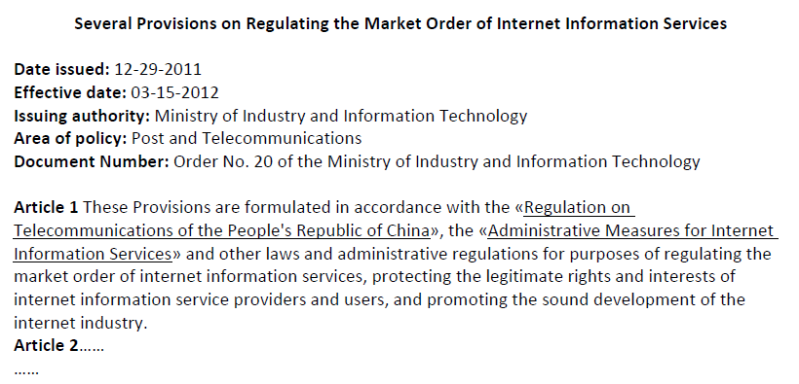
Figure 2 Semi-structured text of an exemplar internet policy of China

It is hence workable to measure the impact of public policies by the citations they received. In addition, the text of policies forms the corpus for co-word analysis. In a co-word analysis (Law et al., 1988; Law and Whittaker, 1992), a couple of words appearing in the same article were used as a basis for multivariate statistical analysis, in order to reflect the proximity between words and reveal the static structures and dynamic evolution of these words. When processing co-word analysis in this study, cluster analysis and multi-dimensional scaling are implemented by the program SPSS 18.0. Collaboration network analysis usually measures network structure with a group of indicators, including density, characteristic path length, etc. It is used to provide the background of collaboration among policy-making agencies. Co-word matrix was constructed by selecting 33 keywords of the highest frequency. Based on results from cluster analysis of the matrix implemented by SPSS 18.0, multi-dimensional scaling, also implemented by SPSS 18.0, presents three topics from China’s Internet policies. This method is statistically effective by Stress=0.152<0.200 and RSQ=0.921>0.800. Each topic in Figure 4 was drawn from the commonalities of the keywords in Table 2 and content of corresponding policies. In the present study, the program NodeXL (http://nodexl.codeplex.com) is used to visualize collaboration networks.

Results
RQ1: Longitudinal trend

Figure 3 shows an overall growth of internet policies the Chinese government issued over the past decades, by counting policy documents by year. It indicates the increasing focus of the Chinese government on the development of internet. However, the number of policies decreased dramatically since 2011, due to the functional transition of the Ministry of Culture (MCPRC). The Provisional Regulations on Administration of Internet Culture (2003) makes it compulsory for commercial internet units to apply for business licenses from the MCPRC. Therefore, a large number of administrative replies appeared in the Internet policies afterwards. However, the administrative authority of the MCPRC was decentralized since the issue of the Notice of the General Office of the Ministry of Culture on Decentralization of administrative approval in 2010, thus leading to a sharp decrease in the number of administrative replies.

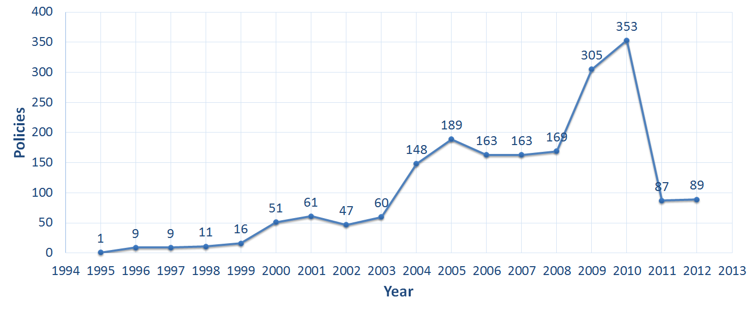
Figure 3 Growth of China’s Internet policies

RQ2: The foci of the Internet Policies

The most popular topic in policy documents (as presented in Figure 4) is “administrative approval”, by the number of keywords and their frequencies, i.e., accumulation of 2,964 frequencies of the seven keywords in the right dashed box. The MCPRC issued a large number of policies concerning administrative replies. Most of the administrative replies concern online banking and electronic authentication services. The former supports e-commerce business, while the latter provides basic services to secure safety and privacy on the internet.

The second was the topic “Internet application: e-commerce, e-government, and e-learning”, with 497 counts of 13 keywords in the top-left dashed box. The keywords concerning e-commerce have the highest frequencies among internet applications. The growth of e-commerce in China is unseen in the traditional retail industry. China’s e-government, although still in an initial stage, develops rapidly (Teng, 2010). Government websites, which provide public service to government information and services, are the major focus of e-government construction. Relevant policies are concern with the building and management of websites, information disclosure and evaluation of their performance. E-learning (or online education) in China is based on physical universities and carried out as pilot construction of online universities.

Last, the topic “Internet regulation” includes 13 keywords and 461 counts in the middle dashed box in Figure 4. It is a recognized and an interdisciplinary field of study (Mueller, 2012), and also challenges worldwide governments. The Chinese government is especially rigorous regarding the governance of internet content. The Great Fire Wall (GFW), China’s national firewall, uses IP blocking, DNS and URL filtering, packet filtering, and connection resetting to pre-filter internet content4. Related policies mainly deal with the remediation of obscene, vulgar and illegal information in internet content, online games, online transactions, and websites.

Figure 4 Three popular topics of China’s Internet policies derived by co-word analysis of 33 high-frequency keywords in China’s internet policies

RQ3: Collaboration Networks of Policy-makers and Citation Networks

Among the 1,931 internet policies, we identified 116 responsible agencies. Table 2 lists 17 most productive agencies, according to the calculation of h-index (Hirsch, 2005), all of which belong to the third group mainly formulating administrative rules or replies. In other words, the number of laws and administrative regulations is relatively low in China’s Internet policies, with most of the policies being administrative rules or replies.

Table 2. Principal agencies of China’s internet policies

Policy-agency | f | Policy-agency | f
Ministry of Culture (MCPRC) | 1,016 | China Banking Regulatory Commission (CBRC) | 33
Ministry of Industry and Information Technology (MIIT) | 147 | China Internet Network Information Center (CNNIC) | 33
Ministry of Education (MOE) | 97 | Ministry of Finance (MOF) | 31
Ministry of Commerce (MOC) | 61 | China Food and Drug Administration (CFDA) | 28
Ministry of Public Security (MPS) | 42 | Ministry of Human Resources and Social Security (MOHRSS) | 20
National Development and Reform Commission (NDRC) | 40 | Ministry of Transport (MOT) | 19
General Administration of Press and Publication (GAPP) | 36 | China Securities Regulatory Commission (CSRC) | 19
State Administration for Industry and Commerce (SAIC) | 34 | State Administration of Taxation (SAT) | 17
State Administration of Radio, Film, and Television (SARFT) | 33
f=Frequency; h(=17)

The collaboration among the 116 agencies forms a weighted and undirected network graph, with the agencies shown as nodes and collaboration as weighted links between nodes. There are 355 links among the 116 nodes. The density of the graph is 0.053 (=355/(116×(116-1)/2)) and the diameter (maximum geodesic distance) is 5. For better visualization, the graph is simplified to a network of h (=17) core nodes in Figure 5, with the density of the simplified graph being 0.603, and its diameter being 3. Overall, the collaboration among the core agencies (in the simplified graph) is significantly more frequent, given the shorter diameter and the much higher graph density. The original graph, with 116 nodes and 355 links, can also be simplified to a network of h (=8) core links, marked by blue nodes and blue links in Figure 5. This sub-network has eight links, the strength of which are at least eight.

Different agencies involve in different internet activities. MCPRC has issued the most internet policies among all the agencies. It is primarily responsible for the management of internet cultural products and services, e.g., online games, internet audio-visual programs and internet cafés, etc. As one of the crucial agencies, MIIT is mainly in charge of internet infrastructure management. MPS guarantees network security, fights cybercrimes and protects the normal functioning of the Internet. SAIC serves as the manager of business licensing of the internet. These four agencies usually work together to regulate Internet cafés. GAP is responsible for internet content and intellectual property, and maintains the market order of internet publication. NDRC is mainly involved in advocating and planning the development of the internet in China. MOF manages the funds and budgets concerning internet development.

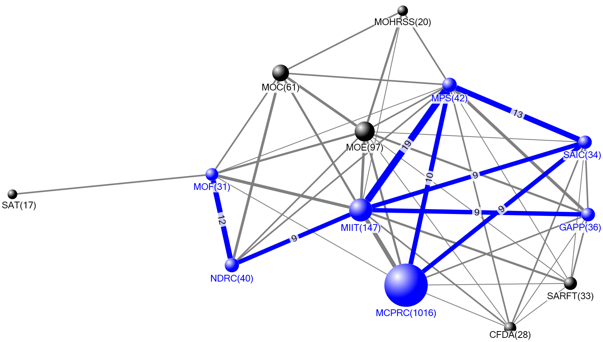
Figure 5 Collaboration network of the core agencies

China's internet regulation appeared a balanced structure parallel to the institutional convergence (Tan, 1999). This is evidenced by the evolution of, for example, MIIT. It was formerly known as Ministry of Information Industry prior to March 2008 which was a combination of both Ministry of Electronics Industry and Ministry of Posts and Telecommunications in March 1998. In Figure 5, the frequencies of the used names have been merged to the frequency of MIIT.

China’s Internet legislation system is primarily composed of administrative rules, but laws and administrative regulations received significantly more citations owing to their superior force. Table 3 lists 15 most highly cited policies. The acronym “R-Y-C” in Table 3 refers to the “ranking” of each policy’s citations, the issue “year” of each policy and the “number of citations” each policy received. Among the 15 highly cited policies, there is one law issued by the SCNPC. In addition, there are one and ten administrative regulations made by the CCCPC and the SC (including the General Office), respectively. The number of laws and administrative regulations accounts for 80.0% of the 15 highly cited policies, although it accounts for only 0.7% of the total 1,931 policies.

Table 3. 15 highly cited Internet polices

R-Y-C | Title | Agency | Type of Policy | Timeliness
1-2000-61 | Regulation on Internet Information Service of the People's Republic of China | SC | Administrative regulations | AMDD on Jan 8 2011
2-2000-32 | Regulation on Telecommunications of the People's Republic of China | SC | Administrative regulations | AMDD on Jul 29 2011
3-2002-29 | Regulations on the Administration of Business Sites of Internet Access Services | SC | Administrative regulations | AMDD on Jan 8 2011
4-2003-26 | Interim Provisions on the Administration of Internet Culture(2003) | MCPRC | Administrative rules | AMDD on Feb 17 2011
5-2007-23 | Regulation of the People's Republic of China on the Disclosure of Government Information | SC | Administrative regulations | Effective
6-2004-21 | Law of the People's Republic of China on Electronic Signature | SCNPC | Law | Effective
7-2001-19 | Interim Measures for the Control of Online Banking Operations(2001) | PBOC | Administrative rules | RPLD on Jan 5 2007
8-2005-16 | Opinions of the General Office of the State Council on Accelerating the development of Electronic Commerce | General Office of SC | Administrative regulations | Effective
9-2003-16 | Measures on the Administration of Reporting Large and Doubtful Payment Transactions in Renminbi | PBOC | Administrative rules | RPLD on Nov 14 2006
10-2004-15 | Opinion on further strengthening and improving ideological and moral construction of minors of CPC Central Committee and State Council | CCCPC & SC | Administrative regulations | Effective
11-2006-14 | Measures for the Administration of Electronic Banking | CBRC | Administrative rules | Effective
12-2004-13 | Decision of the State Council on Establishing Administrative License for the Administrative Examination and Approval Items Really Necessary To Be Retained | SC | Administrative regulations | AMDD on Jan 29 2009
13-1999-13 | Regulation on the Administration of Commercial Cipher Codes | SC | Administrative regulations | Effective
14-2003-13 | Measures for Investigating, Punishing and Banning Unlicensed Business Operations | SC | Administrative regulations | AMDD on Jan 8 2011
15-2001-13 | Regulations of the People's Republic of China on the Administration of Foreign-Funded Financial Institutions(2001) | SC | Administrative regulations | RPLD on Nov 11 2006

The highly cited policies are correlated and form one unbroken directed network, as shown in Figure 6. The bigger the node in Figure 6, the higher citations it received. As the most influential Internet policy, “1-2000-61” is fundamental to policies involving Internet application which is one of the three most popular topics in Internet policies, as revealed in Figure 4. It was issued by the SC in 2000 and amended in 2011. It is noteworthy that none of the other fourteen policies in Table 3 cited “1-2000-61”. Instead, they are connected by co-citations (two documents simultaneously occur in the third one’s references), i.e., the nodes “11-2006-14” and “6-2004-21” in Figure 6 were co-cited by the small node between them. Moreover, most of the significant nodes in Figure 6 are linked indirectly. It indicates that significant internet policies were promulgated independently, rather than dependently. Then, they together became the references of other policies.

Policy “6-2004-21” plays a critical role in the network structure. If it is removed, the network in Figure 6 will break into two. Its left-side sub-network concerns regulation of internet information, and its right-side one focuses on e-commerce. The former received significantly more citations than did the latter. The Regulation on Internet Information Service, as a fundamental policy for Internet regulation, established the system of Internet business management. On this basis, the Chinese government issued a series of supporting policies, e.g., Management Provisions on Electronic Bulletin Services in Internet and Interim Provisions on the Administration of Internet Publication. E-commerce related policies are highly cited in Figure 6 indicating the prosperity of e-commerce in China.

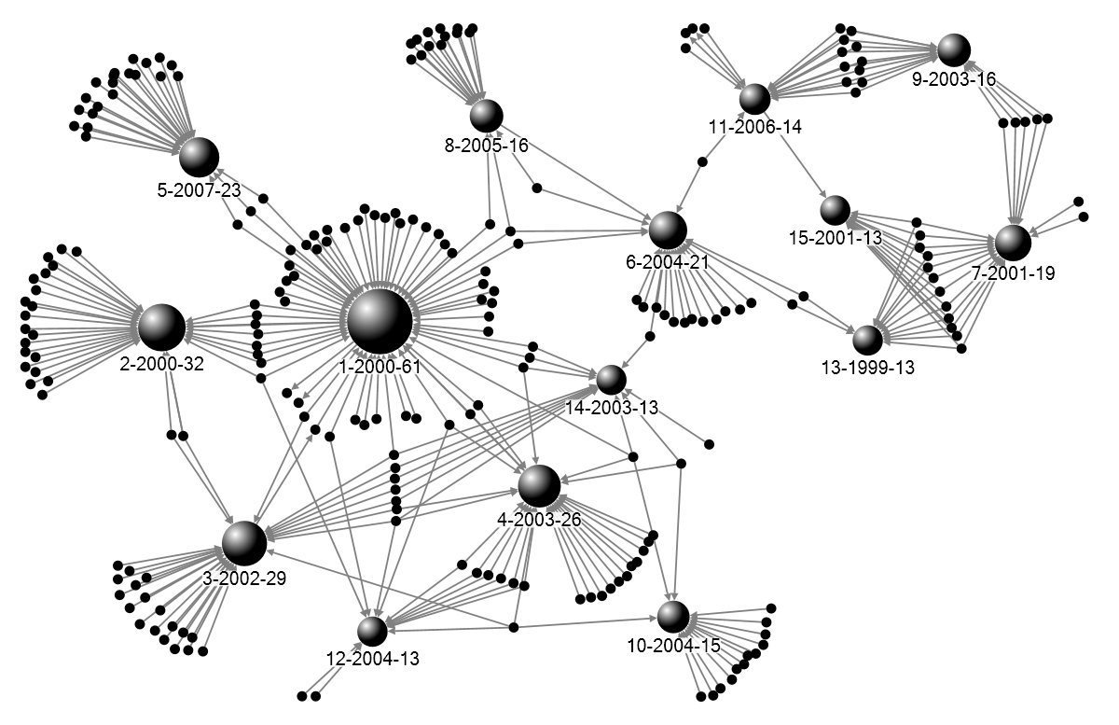
Figure 6 Internet policy citation network (each highly cited policy is labelled in a format: ranking-year-citations
Discussions
Lack of personal information protection

The over-emphasized legislation on internet control, derived from the above results in Section 3.2, overshadowed the focus on personal information protection. For example, legal vacancy caused the prevalence of human-flesh searching (a type of crowdsourcing muckraking initiated by citizens, targeted at public figures and controversial personnel) on the internet in China for years. All aspects of the person who is human-flesh searched, will be completely transparent to the public and lose all privacy in every sense. It is not just data gathering, but also dissemination of personal information to the public. Till December 2012, the SCNPC promulgated the Decision on Strengthening of the Network Information Protection, which for the first time stipulates information security of citizens and legal persons. However, more applicable legislation on human-flesh searching was not promulgated until October 2014, i.e., the Provisions of the Supreme People's Court on Several Issues concerning the Application of Law in the Trial of Cases involving Civil Disputes over Infringements upon Personal Rights and Interests through Information Networks. However, this is far from maturity of legislation on personal data protection. Therefore, it is still necessary for the Chinese government to continue establishing and improving legislative frameworks for personal data protection.

Bureaucracy

Multi-agency governance, as resulted in Section 3.2, sometimes creates hurdles, although bureaucracy is primarily intended to resolve conflicts through the creation of policy and rules among different interest parties. For example, Ng (2009) surveyed and found that complex hierarchy of bureaucracy in China has hindered the development of e-commerce policy in the country’s logistics management (Ng, 2009). In terms of results in this study, it seems excessive to have 116 agencies which were involved in internet policy-making in China, because it far exceeds the number of significant agencies in Figure 2. Most of them appeared only once in the policy system. Therefore, it is necessary for the Chinese government to clarify regulatory responsibilities, in order to avoid policy vacuum and meddle.

The efficiency of the governance system is not as desirable as expected, even if legislation on internet is improved. One reason is that China has no tradition of the rule of law (Zheng, 2007). Though China has legislated a large number of documents on internet, some of them can hardly be enforced. For example, the Chinese government initiated a program named “Internet Real-name System” in 2003. It required netizens to submit their identity certificate information prior to accessing the Internet. This legislation aimed to facilitate internet governance, but remains a regulation on paper. Because internet users and internet service providers boycotted this legislation and showed strong oppositions. However, it is promising to observe the improvement of the rule of law in China, considering the determination of the new central administration. It is valuable to study the gap between legislation and enforcement involving China’s internet in the future.

Limitation

The framework of bibliometric application to policy documents has its limitations. First, the context in which a policy document is cited requires further exploration. It is found that different from article-to-article citation, the number of citations a policy receives is highly correlated to the administrative level of policy-making agencies. Hence, whether citation techniques, unexplored in this study, e.g., bibliographic coupling and co-citation analysis, are applicable to internet policies is an open question. Second, policy documents are subject to very strict hierarchy and subordination. The collaboration among policy-making agencies is under the influence of their administrative level, which is different from the independent collaboration in scientific publications. Therefore, we suggest exploring collaboration networks of policy-making agencies in order to reveal their participation in policy formulation, rather than judging which agency ranks higher in terms of their frequencies in policies. Last, the use of marks “«” and “»” in Chinese policies is not an international practice. Therefore, the techniques of detecting policy references may vary from language to language.

Conclusions

Empirical analysis revealed that China’s internet legislations mainly emphasized e-commerce and internet governance, and, to some extent, neglected data protection. Second, China’s internet is under high-density multiple regulatory controls by central government. A large number of government agencies are involved in internet policy-making, but frequent collaboration is only limited to few agencies, i.e., MIIT, MCPRC, MPS, etc. PD and SILG promulgated fewer policy documents, but occupy higher position in the internet governance hierarchy. Last, China’s internet legislation system is primarily composed of administrative rules, rather than laws or administrative regulations. Nevertheless, laws and administrative regulations received significantly more citations owing to their higher force.

This study also makes methodological contribution to quantitative analysis of public policy documents, which involved four aspects: (a) simple counting of policy documents, which revealed the development of Internet policies; (b) co-word analysis of policy keywords, employed to explore topics of policies; (c) collaboration network analysis of policy-making agencies, designed to identify their participation and responsibilities in policy-making; and (d) citation analysis of public policies as a measure of their citation impact. These techniques combined provide a methodological framework instrumental in revealing the topics involved, citation impact of policies, the roles that agencies play in making policies, as well as their historical evolution.

Acknowledgement

We acknowledge the National Natural Science Foundation of China (NSFC Grant No. 71673242) for financial support.
References
Almind, T.C. & Ingwersen, P. (1997). Informetric analyses on the World Wide Web: methodological approaches to ‘webometrics’. J. Doc. 53(4), 404-426. doi: 10.1108/EUM0000000007205
Björneborn, L., Ingwersen, P. (2004). Toward a basic framework for webometrics. J. Am. Soc. Inf. Sci. Technol. 55(14), 1216-1227. doi: 10.1002/ASI.20077
CNNIC. (2015). Statistical Report on Internet Development in China. http://www1.cnnic.cn/IDR/ReportDownloads/201507/P020150720486421654597.pdf.
Debackere, K. & Glänzel, W. (2004). Using a bibliometric approach to support research policy making: The case of the Flemish BOF-key. Scientometrics. 59(2), 253-276. doi: 10.1023/B:SCIE.0000018532.70146.02
Dong, F. (2012). Controlling the internet in China The real story. Convergence. 18(4), 403-425. doi: 10.1177/1354856512439500
Hirsch, J.E. (2005). An index to quantify an individual's scientific research output. Proc. Natl. Acad. Sci. U. S. A. 102(46), 16569. doi: 10.1073/pnas.0507655102
Huang, C., Su, J., Xie, X., & Li, J. (2014). Basic research is overshadowed by applied research in china: a policy perspective. Scientometrics. 99(3), 689-694. doi: 10.1007/S11192-013-1199-X
Huang, C., Su, J., Xie, X., et al. (2015). A bibliometric study of China’s science and technology policies: 1949–2010. Scientometrics. 102(2), 1521-1539. doi: 10.1007/S11192-014-1406-4
Is slam, M.A. & Hoq, K.M.G. (2010). Community internet access in rural areas: a study on community information centres in Bangladesh. Malays. J. Libr. Sci. 15(2), 109-124.
Jiang, M. (2012). Authoritarian informationalism: china's approach to internet sovereignty. Sais Review. 30(2), 71-89. http://muse.jhu.edu/login?uri=/journals/sais_review/v030/30.2.jiang.html
Kluver, R. (2005). US and Chinese policy expectations of the internet. China Inf. 19(2), 299-324. doi: 10.1177/0920203X05054685
Law, J., Bauin, S., Courtial, J. P., & Whittaker, J. (1988). Policy and the mapping of scientific change: A co-word analysis of research into environmental acidification. Scientometrics. 14(3), 251-264. doi: 10.1007/BF02020078
Law, J. & Whittaker, J. (1992). Mapping acidification research: A test of the co-word method. Scientometrics. 23(3), 417-461. doi: 10.1007/BF02029807
Lieberthal, K., & Burns, J.P. (1995). Governing China: from revolution through reform (p. 356). New York: WW Norton.
Liu, F., & Sun, Y. (2007). The course of, trend in and proposal for evolution from S&T policies to innovation policies: based on the empirical analysis of China’s 289 innovation policy documents. China Soft Science. (5), 34-42. doi: 10.3969/J.ISSN.1002-9753.2007.05.005
Löblich, M. & Karppinen, K. (2014). Guiding Principles for Internet Policy: A Comparison of Media Coverage in Four Western Countries. Inf. Soc. 30(1), 45-59. doi: 10.1080/01972243.2013.855688
McDonald, T. (2015). Affecting relations: domesticating the internet in a south-western Chinese town. Info. Commun. Soc. 18(1), 17-31. doi: 10.1080/1369118X.2014.924981.
Mueller, M.L. (2012) From telecommunications policy to Internet governance. Telecommun. Policy. 36(6), 449–450. doi: 10.1016/J.TELPOL.2012.04.005
National Development and Reform Commission (NDRC), Ministry of Commerce (MOC). (2015). The Catalog of Foreign-funded Industry Guidance. https://hk.lexiscnweb.com/clr/view_article.php?clr_id=98&clr_article_id=1177.
Ng, J.M.J. (2009). Barriers to e-commerce policy in logistics: an exploratory study of the Pearl River Delta, China. Int. J. Logist.-Res. Appl. 12(3), 195-212. doi: 10.1080/13675560802200113
Tague-Sutcliffe, J. (1992). An introduction to informetrics. Inf. Process. Manage. 28(1), 1-3. doi: 10.1016/0306-4573(92)90087-G
Sun, W., Peng, J., Ma, J., & Zhong, W. (2009). Evolution and performance of Chinese technology policy: An empirical study based on “market in exchange for technology” strategy. Journal of Technology Management in China. 4(3), 195-216. doi: 10.1108/17468770911013528
The Editorial Board of the Chinese Library Classification. (2005). Classified Chinese Thesaurus. Beijing: Bejing Library Press.
Tan, Z. (1999). Regulating China's Internet: convergence toward a coherent regulatory regime. Telecommun. Policy. 23(3-4), 261-276. doi: 10.1016/S0308-5961(99)00007-5
Teng, R. (2010). Thinking of China's e-government legislation—from the perspective of the legal system of government information disclosure. Law Science Magazine. 31(6), 131-133. doi: 10.16092/J.CNKI.1001-618X.2010.06.008
Tu, D. (2007). A macro-view on higher education policy-making in China: a quantitative analysis of higher education policy texts from 1979 to 2998. Peking University Education Review. 5(4), 53-65. doi: 1671-9468(2007)04-0053-13
Xue, S. (2005). Internet policy and diffusion in China, Malaysia and Singapore. J. Inf. Sci. 31(3), 238-250. doi: 10.1177/0165551505052472
Yuen, S. (2015). Becoming a Cyber Power: China’s cyber security upgrade and its consequences. China Perspectives. (2), 53-58.
Zittrain, J. & Edelman, B. (2003). Internet filtering in China. IEEE Internet Comput. 7(2), 70-77. doi: 10.1109/MIC.2003.1189191
Zheng, Y. (2007). Technological empowerment: The Internet, state, and society in China. Stanford University Press.

Nanjing University, Nanjing, China; Zhejiang University, Hangzhou, China. li-jiang@zju.edu.cn.
UMass-Amherst, Massachusetts, USA.
Nanjing University, Nanjing, China.
Nanjing University, Nanjing, China.
Nanjing University, Nanjing, China.

